.Literary Term/Academic Vocabulary Activity
You have been assigned 3 terms below (highlighted) for which you will prepare a teaching guide/visual aid.
Juxtaposition Parallelism Voice Tone Infer (Inference)
Syntax Imagery Protagonist Flashback Foreshadowing
Prose Direct Quotation Indirect Quotation Direct Characterization
Indirect Characterization Poetry Narrative
Pathos Ethos Logos

Each word should be on its own 8.5x11” sheet of white paper provided for you.
- The word should be prominently displayed on the paper and spelled correctly.
- Define the term in words that you understand.
- Explain what the term “does” in literature.
- Provide an example from your group novel.
- Illustrate/picture related to the example and/or the definition.
- Provide a question using an NCFE question stem using examples on the back of this page.
Example
Anaphora-The repetition of a certain word or phrase at the beginning of successive lines of writing or speech. It can be used in novels and short stories, but it's most commonly seen in poetry, essays, and formal speeches.
Anaphora…
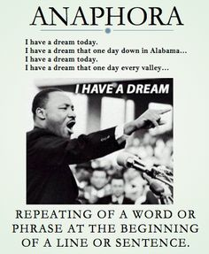
- Appeals to the feelings (pathos) of the audience.
- Helps the reader anticipate the next line.
- Draws attention to something important.

From Deadline- page 9
“I rethink and rethink and rethink and rethink my decision not to tell my brother and my parents, not because I’ve begun to believe I could tolerate how they would treat me after hearing the news, but because I worry about how betrayed they might feel that I didn’t let them prepare.
What is the effect of the use of anaphora in the sentence above?

