Leo Club Spring Community Service Opportunities

Date/Report Time | Event and Location | Responsibilities | Name/Cell # for reminder text
Saturday, April 30  10:30 am  Show runs 11-3 | Lions Club Car Show  Yadkin Bank parking lot  4335 Matthews-Mint Hill Rd, Matthews, NC 28105 | Check in car owners beginning at 10:30 am.  Help with awards.  Help with set up and clean up.
Saturday, May 7  8:30 am  Event runs 9-3 | Discover Mint Hill  Mint Hill Historic Village  7601 Matthews-Mint Hill Rd, Charlotte, NC 28227  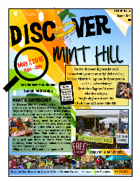 | Help set up tables/tents  Help run booths for local civic organizations and non-profits  Sell Tickets for historic bus ride tour  Help with parking

Date/Report Time | Event and Location | Responsibilities | Name/Cell # for reminder text
Saturday, May 28  7:30 am  Help needed from 7:30-10:30 am | Mint Hill Madness  Lions Club 5K Race  And participation in Parade  Mint Hill Town Hall  4430 Mint Hill Village Lane  Mint Hill, NC 28227 | Register Runners  Provide water to runners on 5K route  Cheer on Runners  Walk to parade staging site and ride on Leo Club float while passing out candy to parade-goers.

